**PWSkills Assignment 03**

**(Done By: Sunandan Sharma)**

**1.**

**Code: (Inline CSS with comments in the code. Inline CSS is overriding both internal and external CSS)**

**(HTML)**

<!DOCTYPE html>

<html lang="en">

<head>

    <meta charset="UTF-8">

    <meta name="viewport" content="width=device-width, initial-scale=1.0">

    <title>Inline CSS Example</title>

    <!-- External CSS -->

    <link rel="stylesheet" href="Style_1_pt1.css">

    <!-- Internal CSS -->

    <style>

        .example1 {

            background-color: lightblue; /* This will be overridden by inline CSS */

            color: black; /* This will be overridden by inline CSS */

        }

    </style>

</head>

<body>

    <div class="example1" style="background-color: yellow; color: red;">

        This box has inline CSS that overrides both internal and external CSS.

    </div>

</body>

</html>

(CSS)

/* External CSS */

.example1 {

    width: 200px;

    height: 100px;

    border: 1px solid black;

    background-color: lightgray; /* This will be overridden by internal CSS */

    color: blue; /* This will be overridden by internal CSS */

}

**Code GitHub link (HTML):** [**Assignment 03 - Q1 (Inline CSS_HTML Code) Link**](https://github.com/Sunandanshrm/Web-Development/blob/master/Frontend/PwSkills/Assignment%2003/index_1_p1.html)

**Code GitHub link (CSS):** [**Assignment 03 - Q1 (Inline CSS_CSS Code) Link**](https://github.com/Sunandanshrm/Web-Development/blob/master/Frontend/PwSkills/Assignment%2003/Style_1_pt1.css)

**The Output:**

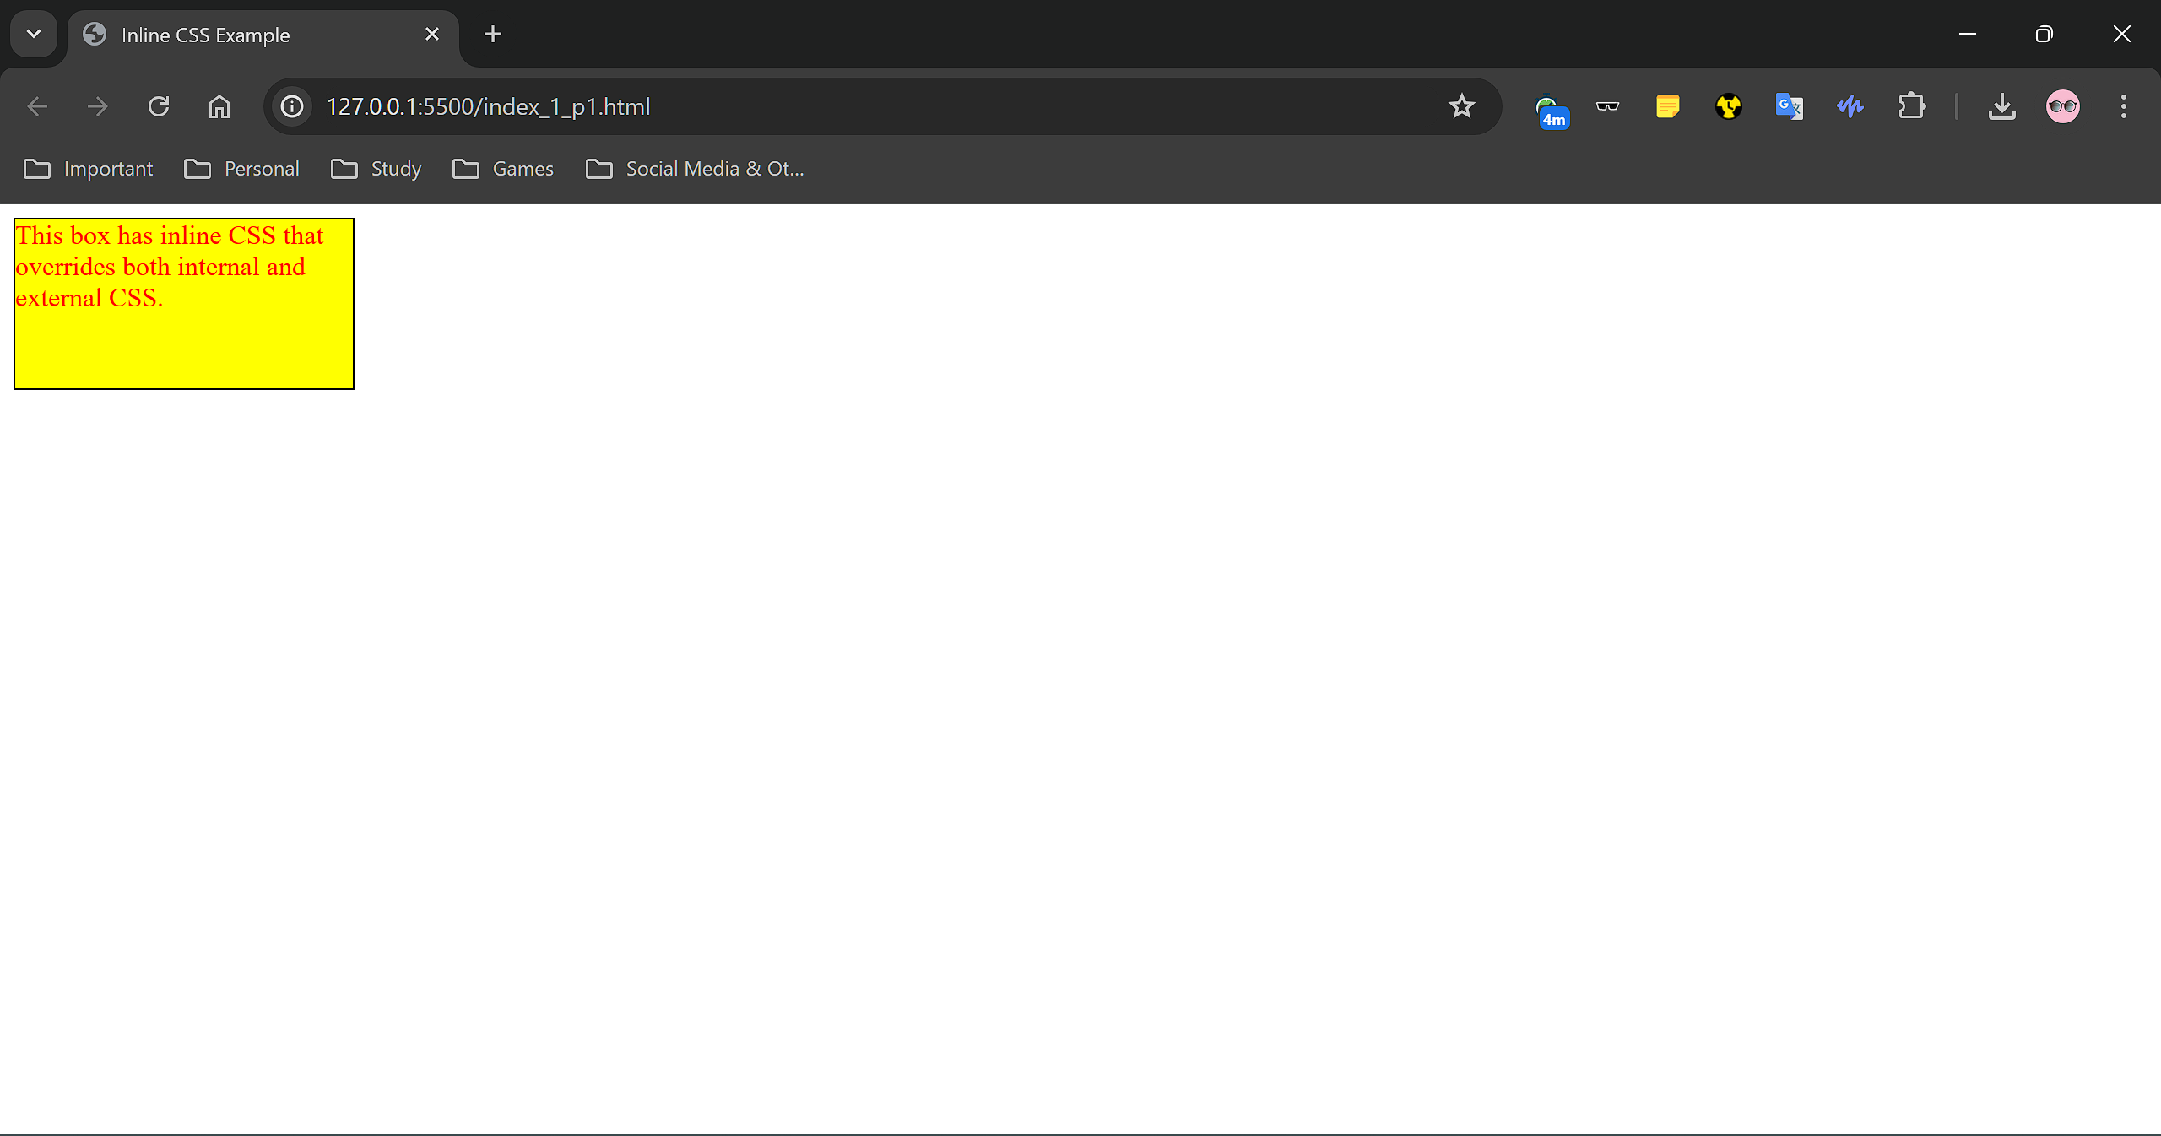

**Code: (Internal CSS with comments in the code. Internal CSS is overriding external CSS)**

**(HTML)**

<!DOCTYPE html>

<html lang="en">

<head>

    <meta charset="UTF-8">

    <meta name="viewport" content="width=device-width, initial-scale=1.0">

    <title>Internal CSS Example</title>

    <!-- External CSS -->

    <link rel="stylesheet" href="Style_1_pt2.css">

    <!-- Internal CSS -->

    <style>

        .example2 {

            background-color: lightgreen; /* This will override external CSS */

            color: purple; /* This will override external CSS */

        }

    </style>

</head>

<body>

    <div class="example2">

        This box has internal CSS that overrides external CSS.

    </div>

</body>

</html>

**(CSS)**

/* External CSS */

.example2 {

    width: 200px;

    height: 100px;

    border: 1px solid black;/* This will be overridden by internal CSS */

    background-color: lightgray;/* This will be overridden by internal CSS */

    color: blue;

}

**Code GitHub link (HTML):** [**Assignment 03 - Q1 (Internal CSS_HTML Code) Link**](https://github.com/Sunandanshrm/Web-Development/blob/master/Frontend/PwSkills/Assignment%2003/index_1_pt2.html)

**Code GitHub link (CSS):** [**Assignment 03 - Q1 (Internal CSS_CSS Code) Link**](https://github.com/Sunandanshrm/Web-Development/blob/master/Frontend/PwSkills/Assignment%2003/Style_1_pt2.css)

**The Output:**

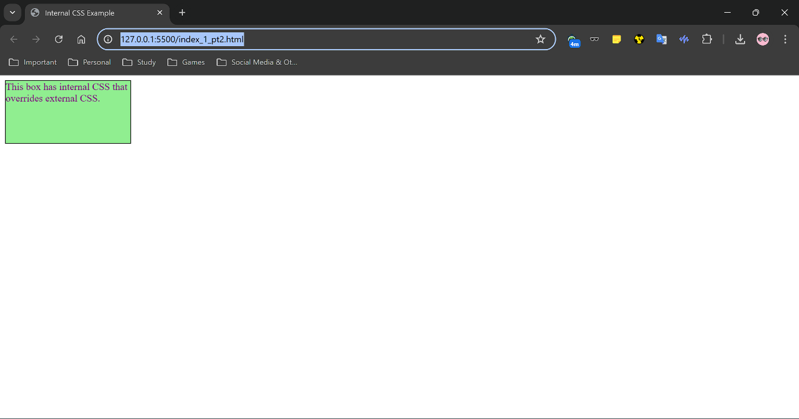

**Code: (External CSS with comments in the code.)**

**(HTML)**

<!DOCTYPE html>

<html lang="en">

<head>

    <meta charset="UTF-8">

    <meta name="viewport" content="width=device-width, initial-scale=1.0">

    <title>External CSS Example</title>

    <!-- External CSS -->

    <link rel="stylesheet" href="Style_1_pt3.css">

</head>

<body>

    <div class="example3">

        This box has External CSS.

    </div>

</body>

</html>

**(CSS)**

/* External CSS */

.example3 {

    width: 200px;

    height: 100px;

    border: 1px solid black;/* This will be overridden by internal CSS */

    background-color: lightgray;/* This will be overridden by internal CSS */

    color: blue;

}

**Code GitHub link (HTML):** [**Assignment 03 - Q1 (External CSS_HTML Code) Link**](https://github.com/Sunandanshrm/Web-Development/blob/master/Frontend/PwSkills/Assignment%2003/index_1_pt3.html)

**Code GitHub link (CSS):** [**Assignment 03 - Q1 (External CSS_CSS Code) Link**](https://github.com/Sunandanshrm/Web-Development/blob/master/Frontend/PwSkills/Assignment%2003/Style_1_pt3.css)

**The Output:**

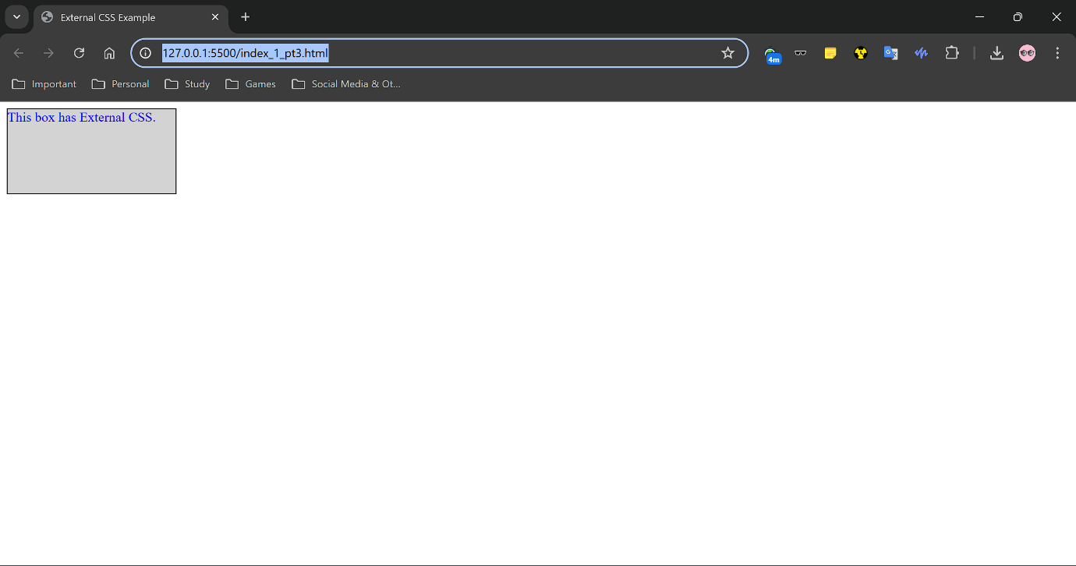

**2.** Here we use the **“BEM”** (Block, Element, Modifier) naming convention for CSS class selectors such that we can give individual design to each paragraph. The **“Block”** here is the class **“content”** and the **“Element”** here is **“content_paragraph”** then we denote the **“Modifier”** names like **“content_paragraph - - highlight”**, **“content_paragraph - -large text”** etc. From the name given to the modifiers we can readily detect the properties they control of the element.

**Code: (BEM Naming Convention example)**

**(HTML)**

<!DOCTYPE html>

<html lang="en">

<head>

    <meta charset="UTF-8">

    <meta name="viewport" content="width=device-width, initial-scale=1.0">

    <title>BEM Naming Convention Example</title>

    <link rel="stylesheet" href="Style_2.css">

</head>

<body>

    <div class="content">

        <p class="content__paragraph content__paragraph--highlight">This is the first paragraph with a highlight background.</p>

        <p class="content__paragraph content__paragraph--large-text">This is the second paragraph with larger text.</p>

        <p class="content__paragraph content__paragraph--italic">This is the third paragraph in italic.</p>

        <p class="content__paragraph content__paragraph--bold">This is the fourth paragraph in bold.</p>

        <p class="content__paragraph content__paragraph--underlined">This is the fifth paragraph with an underline.</p>

    </div>

</body>

</html>

**(CSS)**

body {

    font-family: Arial, sans-serif;

    margin: 0;

    padding: 20px;

}

.content {

    margin: 0 auto;

    max-width: 800px;

}

.content__paragraph {

    margin-bottom: 20px;

    padding: 10px;

    border: 1px solid #ccc;

    border-radius: 4px;

}

.content__paragraph--highlight {

    background-color: #ffeb3b;

}

.content__paragraph--large-text {

    font-size: 1.5em;

}

.content__paragraph--italic {

    font-style: italic;

}

.content__paragraph--bold {

    font-weight: bold;

}

.content__paragraph--underlined {

    text-decoration: underline;

}

**Code GitHub link (HTML):** [**Assignment 03 - Q2 (BEM naming convention HTML Code) Link**](https://github.com/Sunandanshrm/Web-Development/blob/master/Frontend/PwSkills/Assignment%2003/index_2.html)

**Code GitHub link (CSS):** [**Assignment 03 - Q2 (BEM naming convention CSS Code) Link**](https://github.com/Sunandanshrm/Web-Development/blob/master/Frontend/PwSkills/Assignment%2003/Style_2.css)

**The Output:**

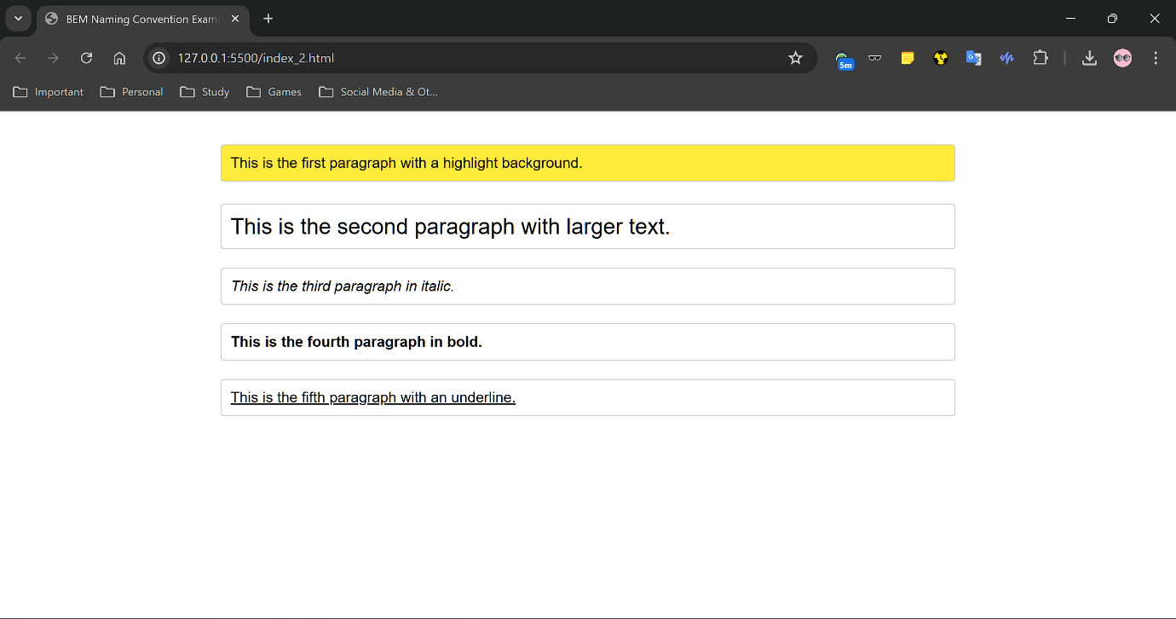

**3.**

**Code: (Stylized HTML Form)**

**(HTML)**

<!DOCTYPE html>

<html lang="en">

<head>

    <meta charset="UTF-8">

    <meta name="viewport" content="width=device-width, initial-scale=1.0">

    <title>Styled HTML Form</title>

    <link rel="stylesheet" href="Style_3.css">

</head>

<body>

    <div class="form-container">

        <h1>Contact Us</h1>

        <form>

            <fieldset class="form-section">

                <legend>Personal Information</legend>

                <label for="name">Name:</label>

                <input type="text" id="name" name="name">

                <label for="email">Email:</label>

                <input type="email" id="email" name="email">

                <label for="phone">Phone:</label>

                <input type="tel" id="phone" name="phone">

            </fieldset>

            <fieldset class="form-section form-section--with-opacity">

                <legend>Address</legend>

                <label for="address">Street Address:</label>

                <input type="text" id="address" name="address">

                <label for="city">City:</label>

                <input type="text" id="city" name="city">

                <label for="state">State:</label>

                <input type="text" id="state" name="state">

                <label for="zip">ZIP Code:</label>

                <input type="text" id="zip" name="zip">

            </fieldset>

            <button type="submit">Submit</button>

        </form>

    </div>

</body>

</html>

**(CSS)**

/* Custom Color Palette */

:root {

    --primary-color: #3498db; /* Blue */

    --secondary-color: #2ecc71; /* Green */

    --background-color: #f4f4f4; /* Light grey */

    --input-background-color: #ecf0f1; /* Very light grey */

    --button-color: #e74c3c; /* Red */

    --text-color: #333; /* Dark grey */

    --section-opacity: 0.8;

}

body {

    font-family: Arial, sans-serif;

    background-color: var(--background-color);

    margin: 0;

    padding: 20px;

}

.form-container {

    max-width: 600px;

    margin: 0 auto;

    padding: 20px;

    background-color: white;

    border-radius: 8px;

    box-shadow: 0 0 10px rgba(0, 0, 0, 0.1);

}

h1 {

    text-align: center;

    color: var(--primary-color);

}

form {

    display: flex;

    flex-direction: column;

}

.fieldset {

    border: 1px solid var(--primary-color);

    border-radius: 4px;

    padding: 5px;

    margin-bottom: 20px;

}

.legend {

    color: var(--secondary-color);

    font-weight: bold;

}

label {

    margin-bottom: 5px;

    color: var(--text-color);

}

input[type="text"],

input[type="email"],

input[type="tel"]

 {

    width: 90%;

    padding: 15px;

    margin-bottom: 10px;

    border: 1px solid var(--primary-color);

    border-radius: 4px;

    background-color: var(--input-background-color);

}

button {

    padding: 10px 20px;

    background-color: var(--button-color);

    color: white;

    border: none;

    border-radius: 4px;

    cursor: pointer;

}

button:hover {

    background-color: var(--secondary-color);

}

/* Apply opacity to one of the form sections */

.form-section--with-opacity {

    opacity: var(--section-opacity);

}

**Code GitHub link (HTML):** [**Assignment 03 - Q3 (Styled HTML Form HTML Code) Link**](https://github.com/Sunandanshrm/Web-Development/blob/master/Frontend/PwSkills/Assignment%2003/index_3.html)

**Code GitHub link (CSS):** **[Assignment 03 - Q3 (Styled HTML Form CSS Code) Link](https://github.com/Sunandanshrm/Web-Development/blob/master/Frontend/PwSkills/Assignment%2003/Style_3.css)**

**The Output:** [**Assignment 03 - Q3 (Styled HTML Output) Link**](https://drive.google.com/file/d/1P298gEEZCIkUACgjMcnG2NYpoJQOxlkw/view?usp=drive_link)